Analytics for Observational Data (IT142IU)
  - Lab 3-4: PCA

Objectives
- Calculate covariances and correlations given datasets.
- Apply PCA to select features.
- Dataset sources:
  - Sample.dataset.csv (provided on the Blackboard)
  - silicon-wafer-thickness.csv (provided on the Blackboard)
- Programming languages: Python/Java

Analyzing the data
Part 1.
Questions | Answers
Dataset name | Sample.dataset.csv
Correlation before PCA | 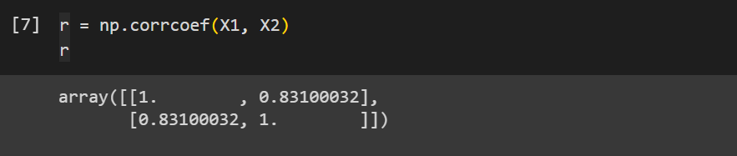
Covariance before PCA | 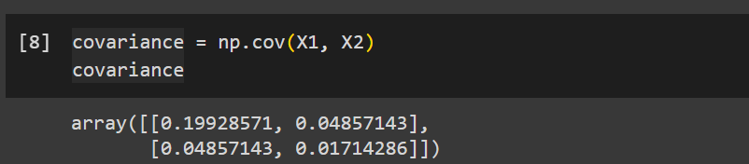
Eigenvalues and  Eigenvectors | 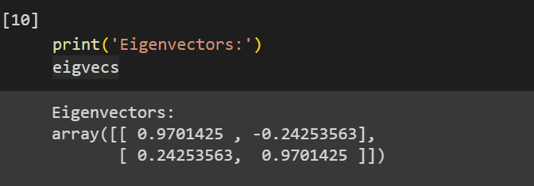  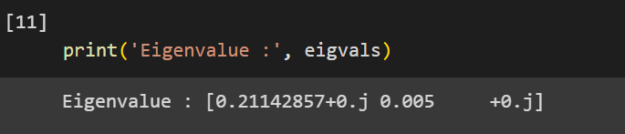
Data after standardizing | 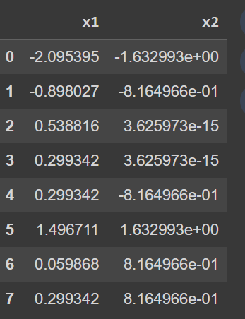
New data after PCA | 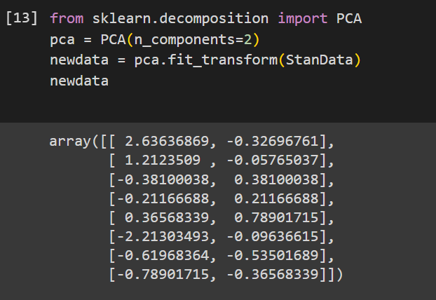
Correlation after PCA | 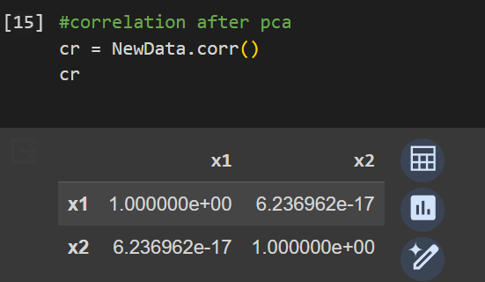
Covariance after PCA | 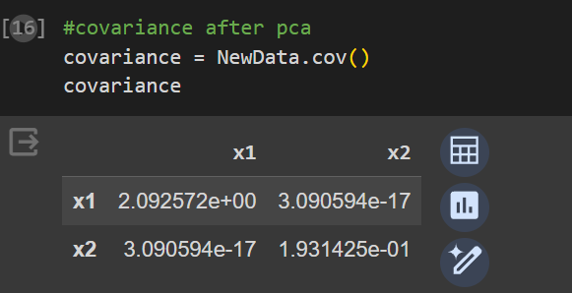
Remarks

Part 2.
Questions | Answers
Dataset name | silicon-wafer-thickness
Correlation matrix before PCA | 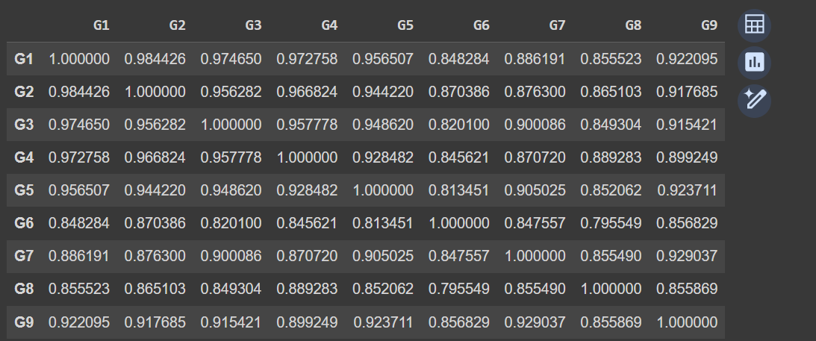
Covariance matrix before PCA | 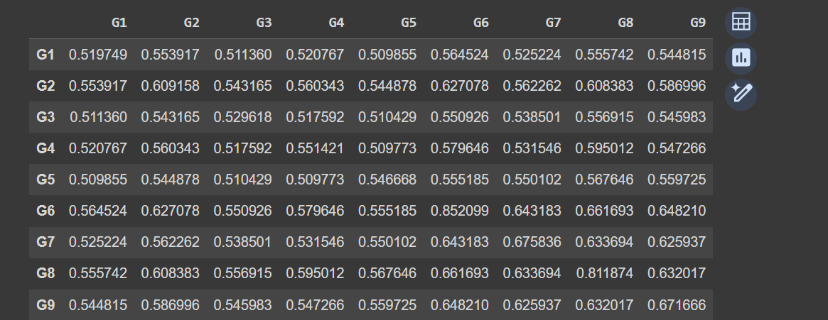
Eigenvalues and  Eigenvectors | 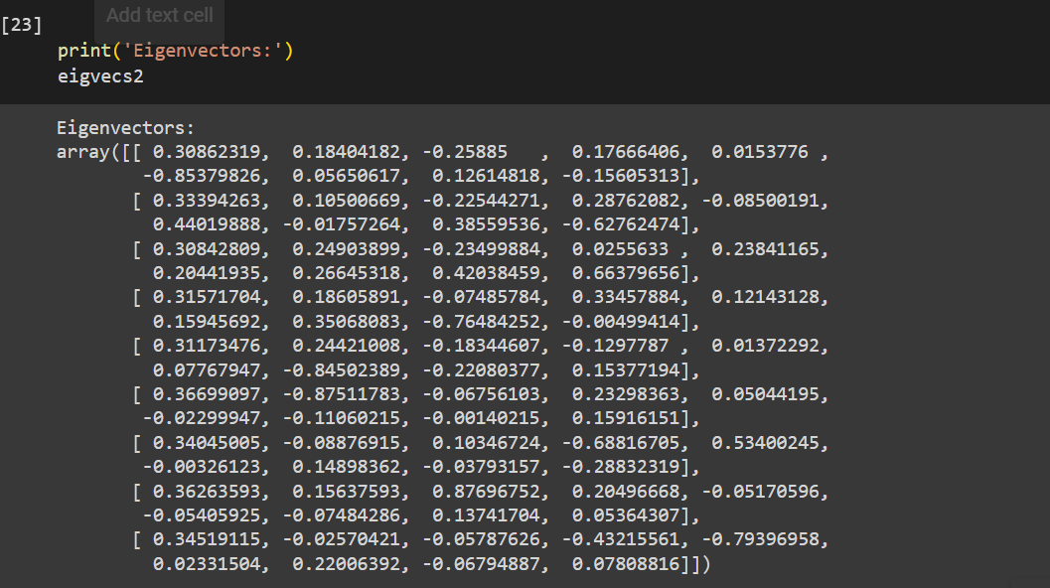  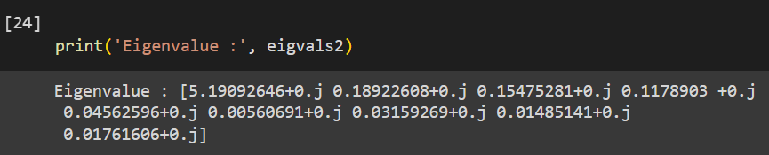
Data after standardizing | 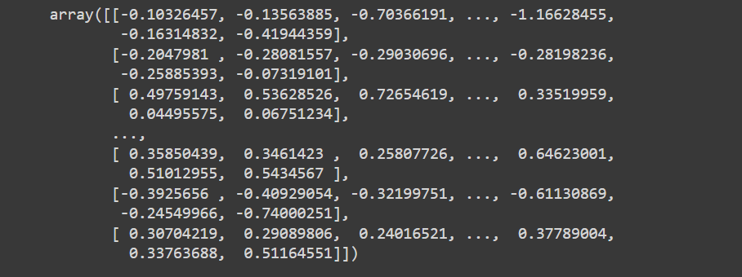
New data after PCA using 4 components | 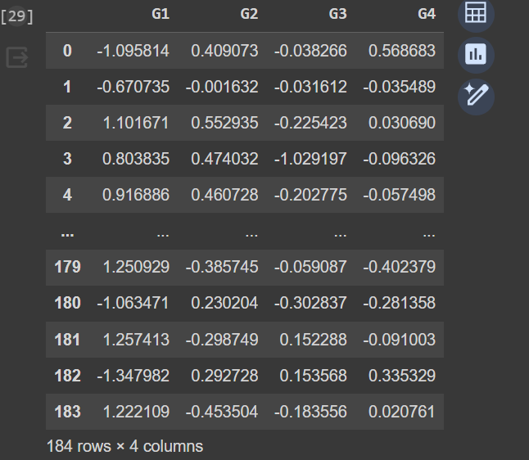
Correlation after PCA | 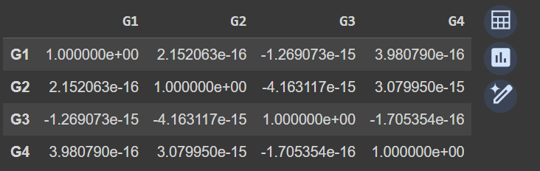
Covariance after PCA | 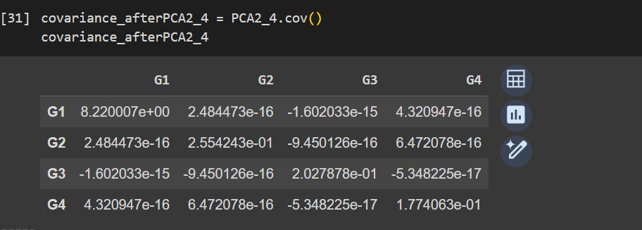
New data after PCA using 8 components | 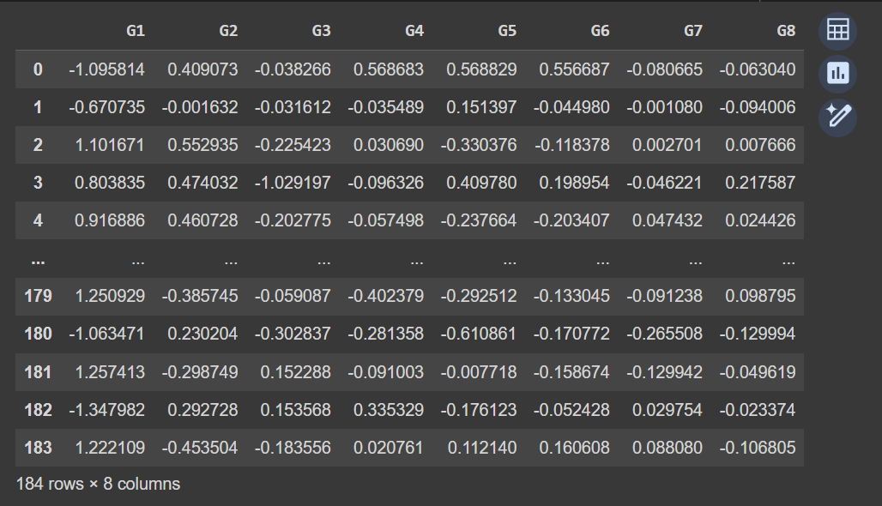
Correlation after PCA | 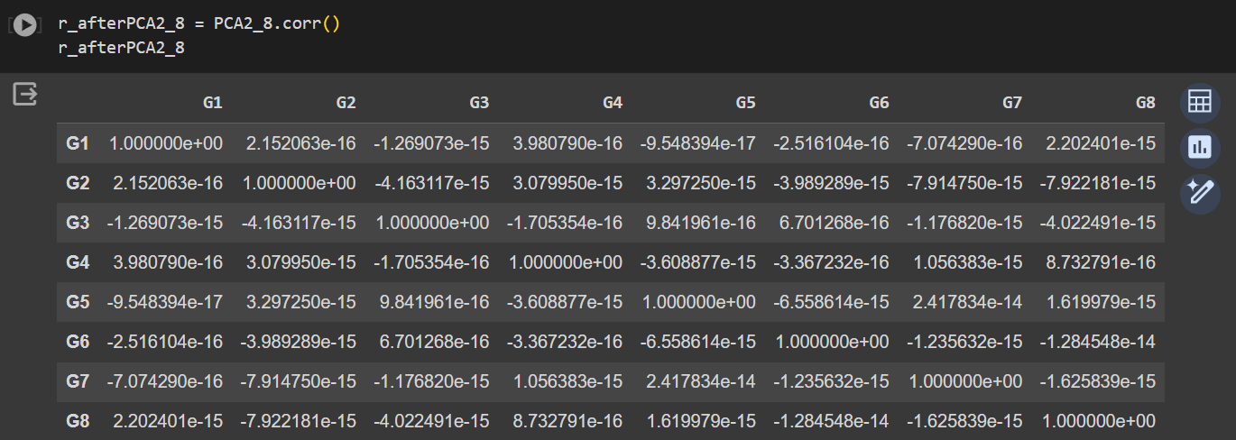
Covariance after PCA | 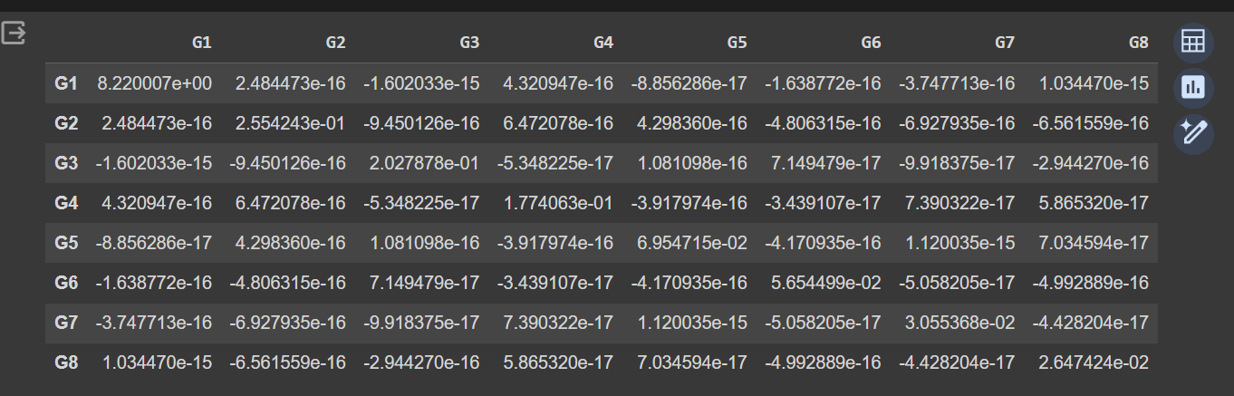
Plot the scores for the first two components. What do you notice? Investigate the outliers, and the raw data for each of these unusual observations. What do you conclude about those observations? | 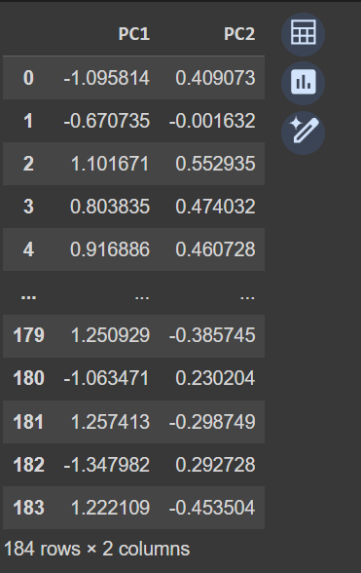  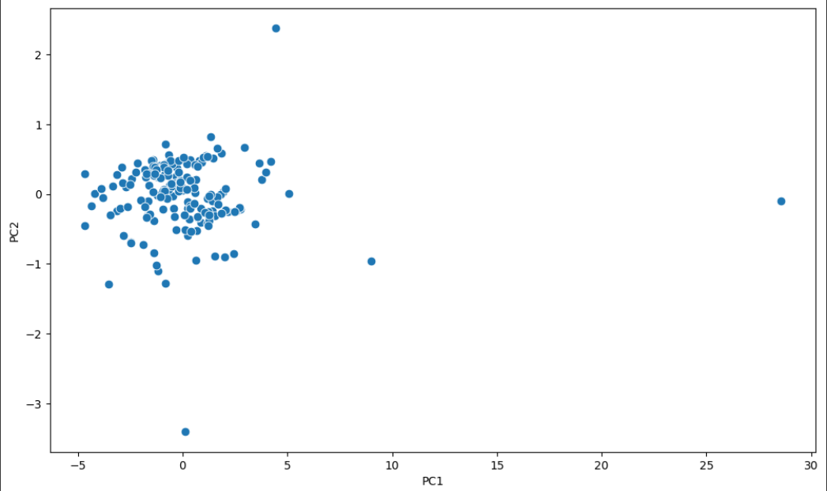
Exclude the unusual observations and refit the PCA model. | 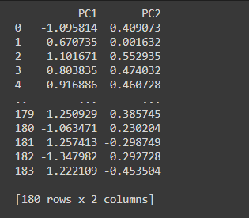  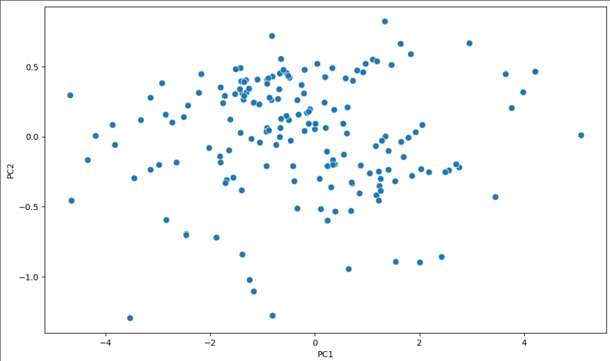
Remarks

Part 3
Questions | Answers
Dataset name | silicon-wafer-thickness
Use sklearn.decomposition  to build a PCA model on all the data | 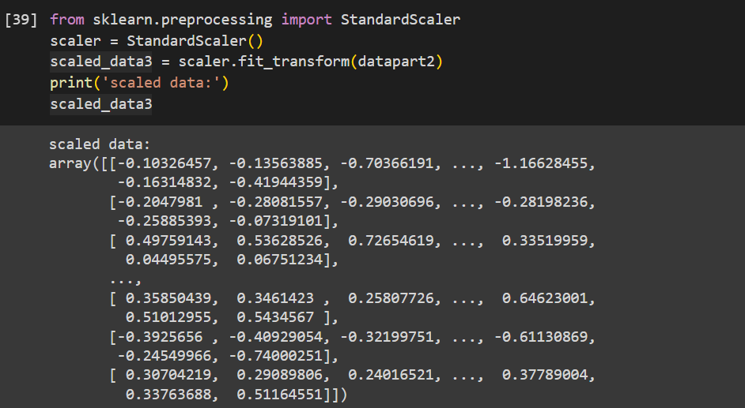
Correlation after PCA | 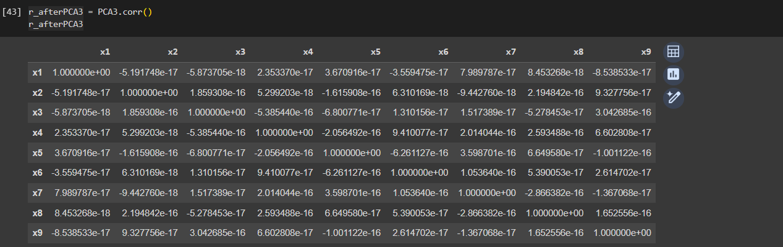
Covariance after PCA | 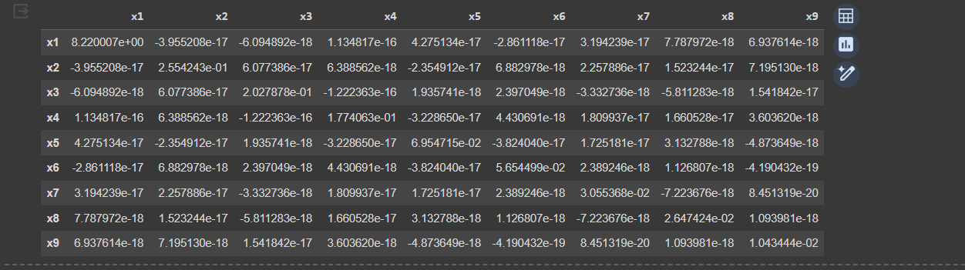
Compare with the above results and evaluate | 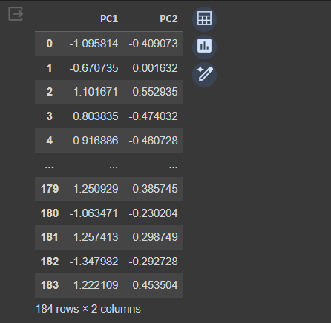  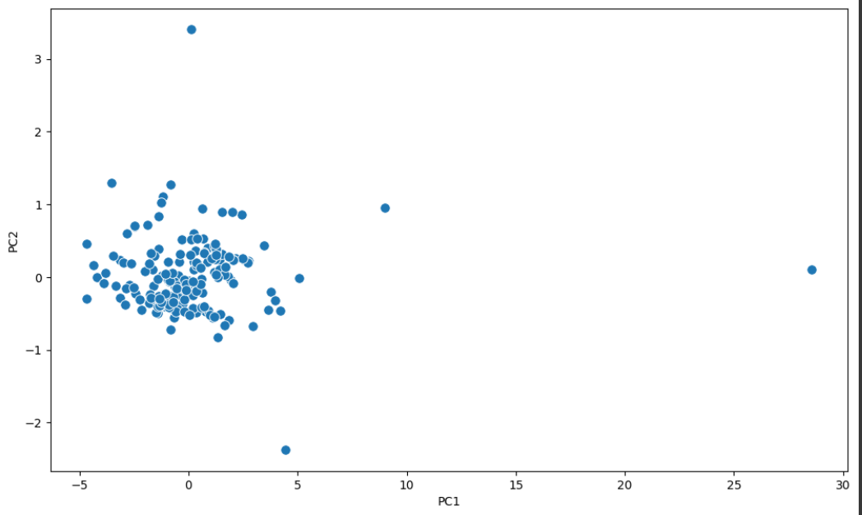
Plot the scores for the first two components. What do you notice? Investigate the outliers, and the raw data for each of these unusual observations. What do you conclude about those observations? | 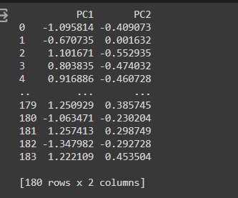  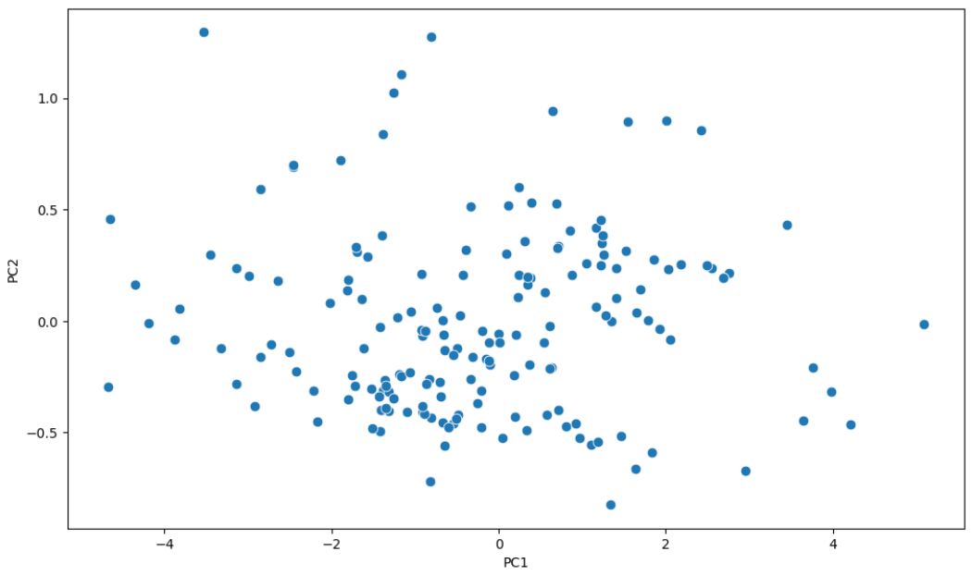
Exclude the unusual observations and refit the PCA model.

Remarks

Some references
- PCA: https://builtin.com/data-science/step-step-explanation-principal-component-analysis
- Compute the eigenvalues and right eigenvectors: https://numpy.org/doc/stable/reference/generated/numpy.linalg.eig.html
- Standardization: https://scikit-learn.org/stable/modules/generated/sklearn.preprocessing.StandardScaler.html
- PCA in Python: https://scikit-learn.org/stable/modules/generated/sklearn.decomposition.PCA.html
- Learn more about PCA: https://learnche.org/pid/latent-variable-modelling/principal-component-analysis/pca-exercises

